Latest News: 5th March 2020

Sri Lanka Women’s Swimming Project
~ The Movie ~
We are delighted to report that www.icanswimcanyou.com founded by Christina Fonfe´ immediately following the 2004 Boxing Day Tsunami, is the subject of one of 64 just documentaries chosen from a record 6,100 submissions for Premiering at New York’s famous 2020 Tribeca Film Festival. Christina is, of course, well known for espousing the ability to Float-and-Breathe as the single most important self-preservation water safety skill to be learned above all others. Sadly, Covid cancelled the Film Festival 2020 but we are hopeful the film will be released for showing later in 2021 and maybe it may even win! Here are the words straight from the horse’s mouth… Look out for the Poster.

Source: https://www.tribecafilm.com/news/2020-tribeca-film-festival-shorts

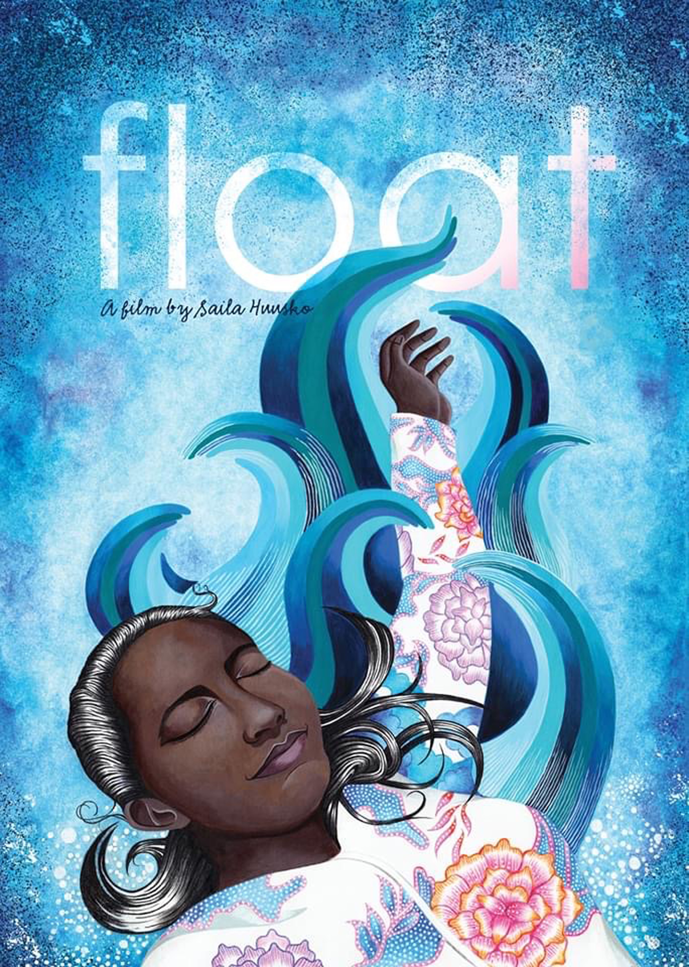
The most beautiful poster ever, produced for Drowning Prevention Movie ‘Float’

